HutchDelivery

Preview

# Pages

## Home Page (English)

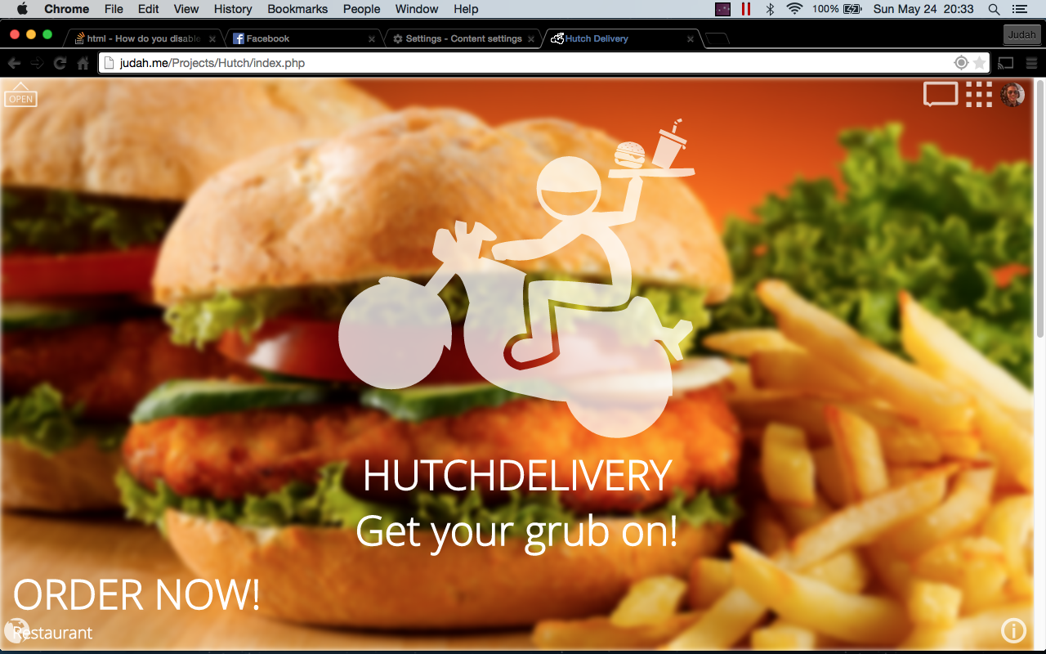

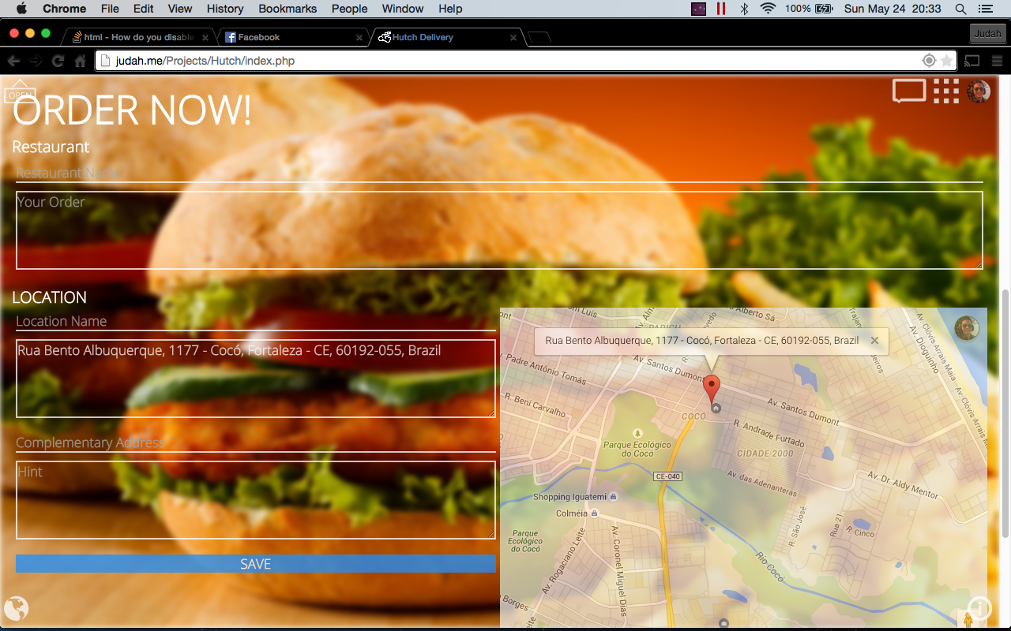

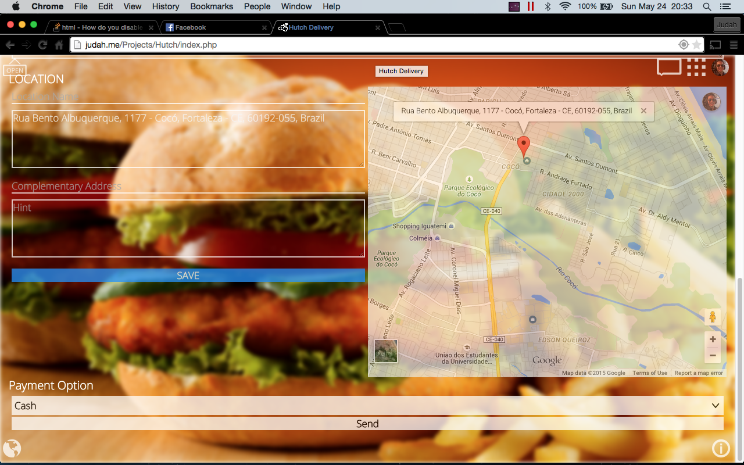

## Home PAGE (Português)

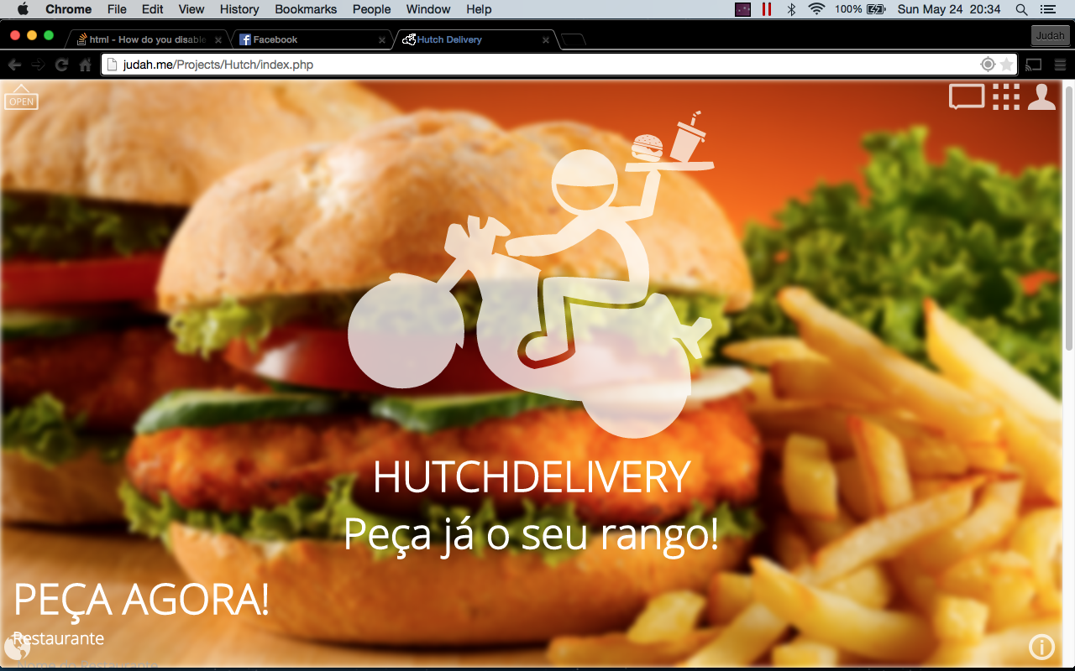

## GOODS

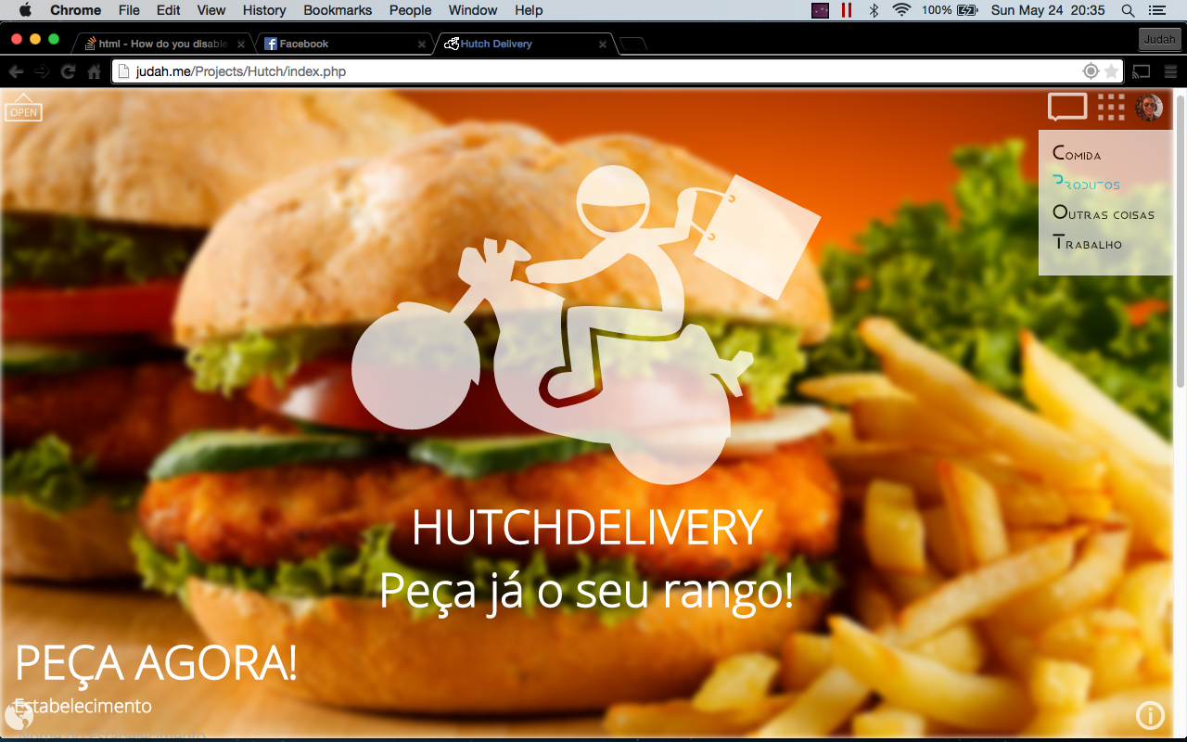

# Project Features

## Facebook Login

The Project preview already uses Facebook Login (but it still needs a database)

## GeoLocation

The Project preview already uses Google Geolocation to get the user Address and position.

## Smart Cache

The Project preview already uses cache to improve performance.

## No BlaNK loading web pages

The Project preview already uses has a special loading that does not show a blank page (like Facebook) when it is loading another one; instead it uses a progress bar just like YouTube.

## Supports Plug And Play Language

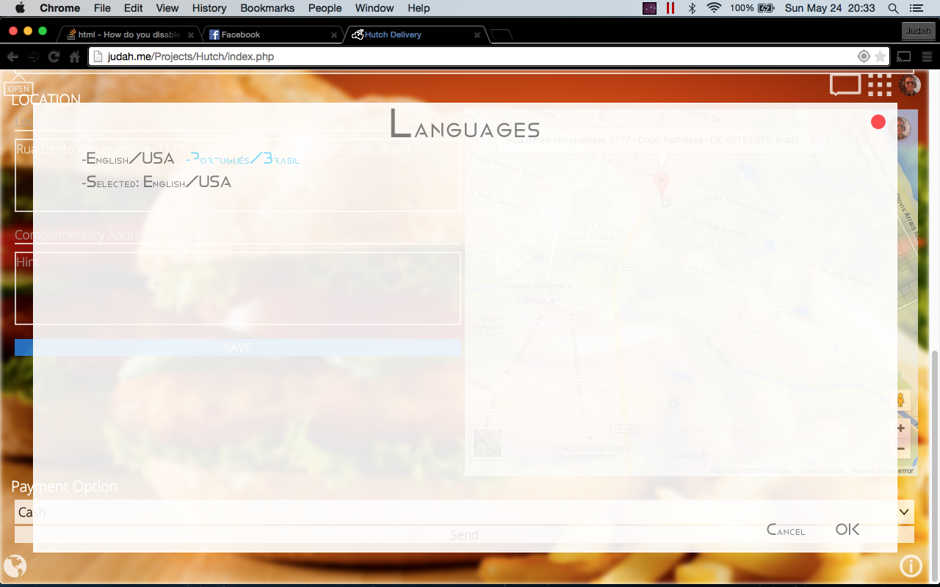

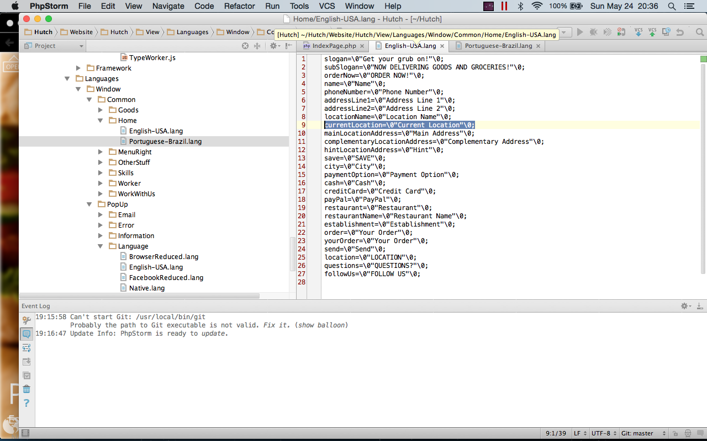

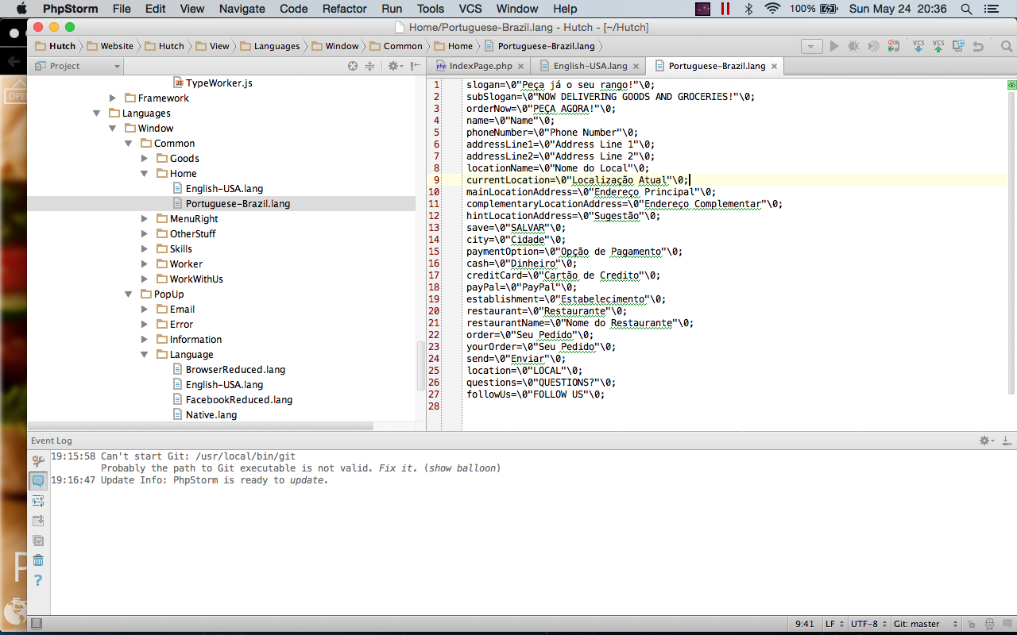

## Modular Programming

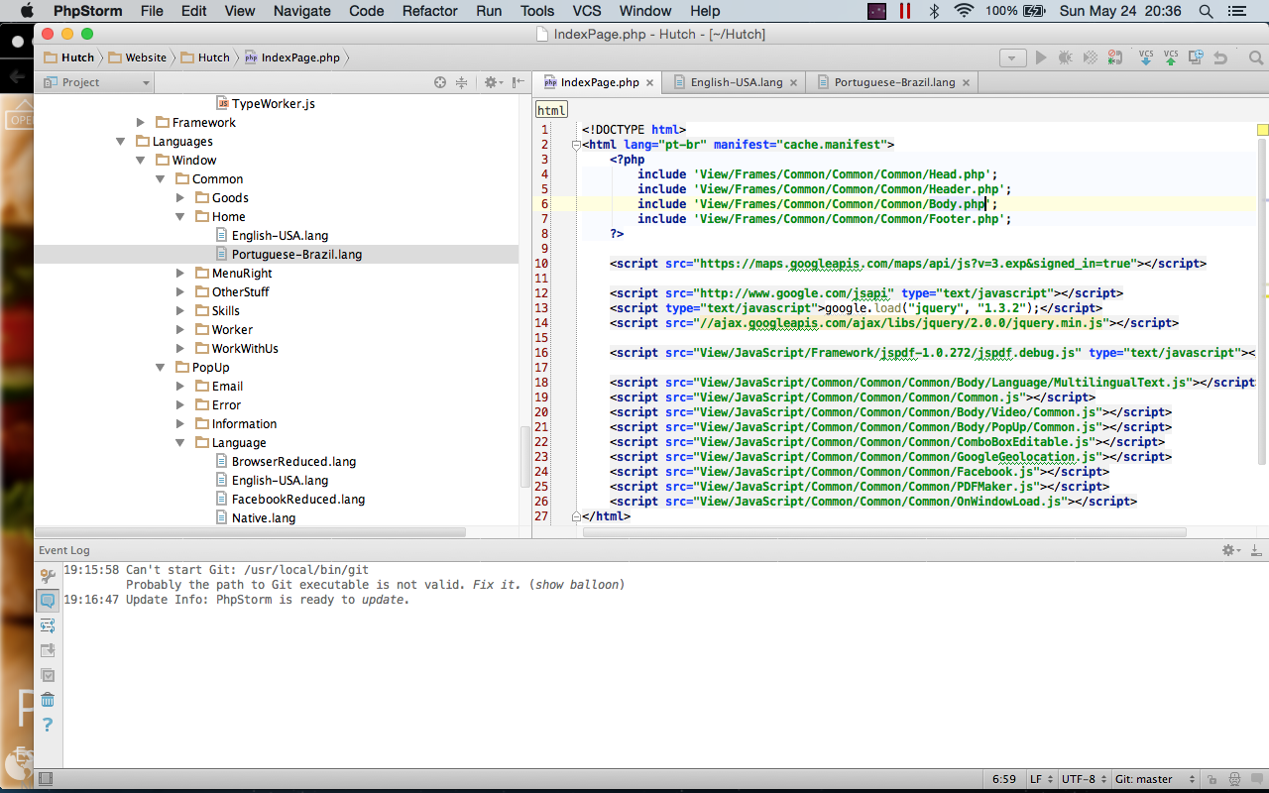

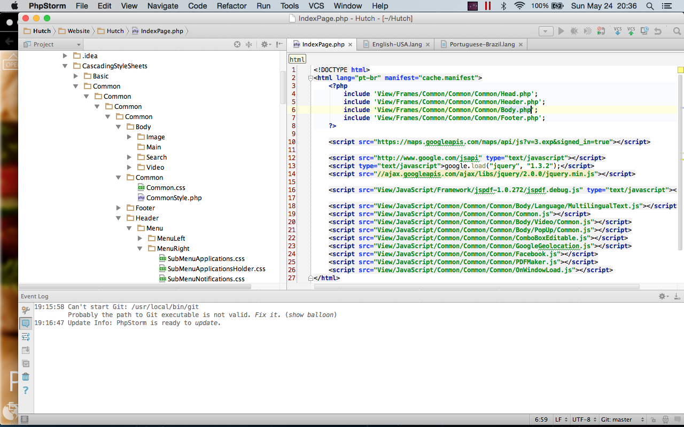

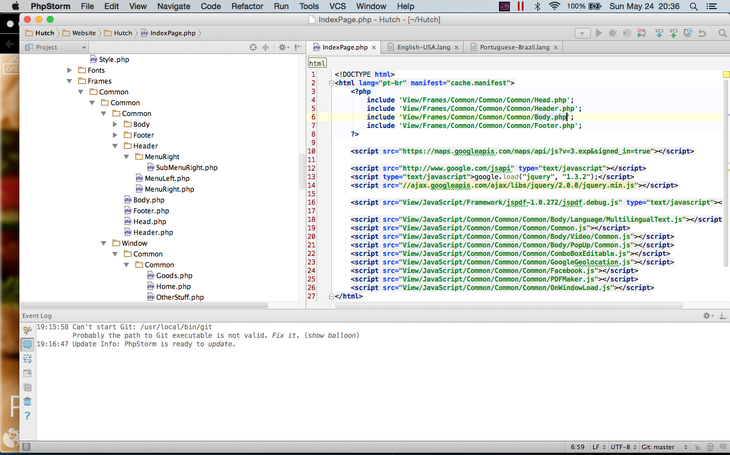

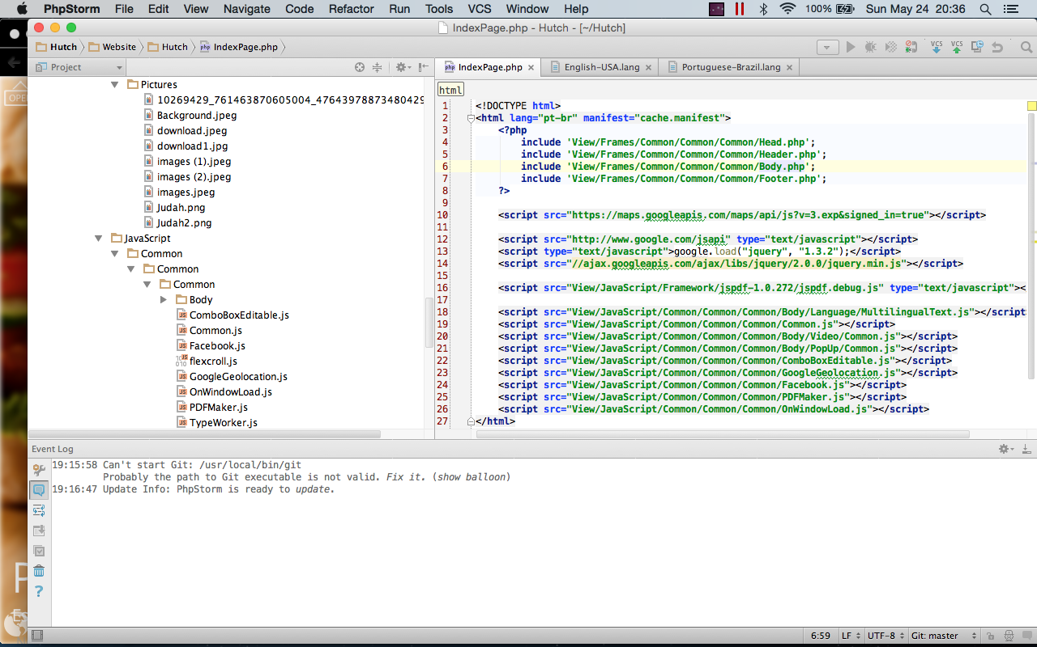

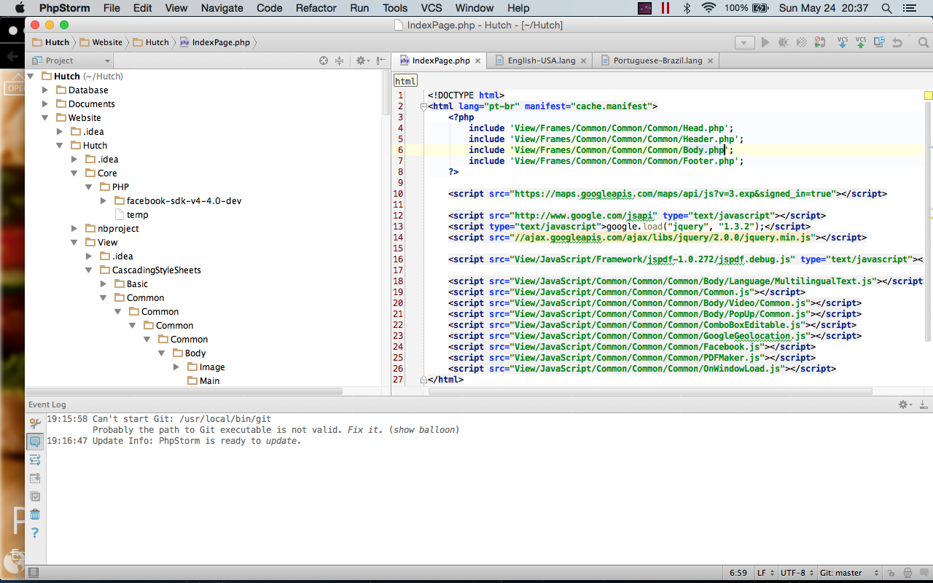

# Database Project

